**Android Custom Listview with Image and Text using ArrayAdapter**

Posted by [R.K.Kanojia (Android App Developer)](http://www.androidinterview.com/author/rkkanojia7/)

Custom Listview with Image and Text :

The standard [ListView](http://www.androidinterview.com/android-simple-listiview-example/" \o "Displaying a List of Items Using the ListView in Android) only displays a list of items. while it may suffice when you simply need to show a list of text, it’s not enough for more refined applications. in this example, you’ll see how you’ll be able to customise the [ListView](http://www.androidinterview.com/android-simple-listiview-example/" \o "Displaying a List of Items Using the ListView in Android)so that you’ll be able to show pictures, multiple lines of text, and more.

[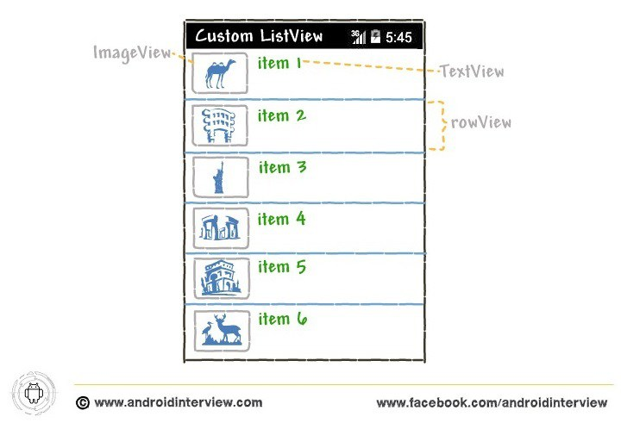](http://i1.wp.com/www.androidinterview.com/wp-content/uploads/2014/09/custom-listview-image-text1.jpg)

A. First Learn How to Display Image in ListView :

1. The first thing you’ll learn in this example is how to show a picture next to each item in the ListView. To do that, Create an XML file in your **res/layout** folder and name it, for example, **mylist.xml**

[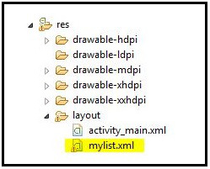](http://i1.wp.com/www.androidinterview.com/wp-content/uploads/2014/09/custom-listview-image-text3.jpg)

2. Now Open “**res/layout/mylist.xml**” file and put this xml code it into file:

mylist.xml

XHTML



|  |  |
| --- | --- |
| 1  2  3  4  5  6  7  8  9  10  11  12  13  14  15  16  17  18  19  20 | <LinearLayout xmlns:android="http://schemas.android.com/apk/res/android"  android:layout_width="fill_parent"  android:layout_height="fill_parent"  android:orientation="horizontal" >  <ImageView  android:id="@+id/icon"  android:layout_width="50dp"  android:layout_height="50dp"  android:layout_marginBottom="5dp"  android:layout_marginLeft="5dp"  android:layout_marginRight="5dp"  android:layout_marginTop="5dp"  android:src="@drawable/ic_launcher" />  <TextView  android:id="@+id/Itemname"  android:layout_width="wrap_content"  android:layout_height="wrap_content"  android:textSize="20sp"  android:paddingTop="5dp"/>  </LinearLayout> |

Above code will show each row will contain an ImageView and a TextView.

3. To display a ListView in your activity, you need to add the *<ListView>* element to your UI, such as the**activity_main.xml** file:

*File : res/layout/activity_main.xml*

activity_main.xml

Java



|  |  |
| --- | --- |
| 1  2  3  4  5  6  7  8  9  10  11 | <RelativeLayout xmlns:android="http://schemas.android.com/apk/res/android"      xmlns:tools="http://schemas.android.com/tools"      android:layout_width="match_parent"      android:layout_height="match_parent"      tools:context="{relativePackage}.${activityClass}" >    <ListView  android:id="@+id/android:list"  android:layout_width="fill_parent"  android:layout_height="fill_parent" />  </RelativeLayout> |

1. Open “**MainActivity.java**” file and add following JAVA code.

*File : src/package-name/MainActivity.java*

MainActivity.java

Java



|  |  |
| --- | --- |
| 1  2  3  4  5  6  7  8  9  10  11  12  13  14  15  16  17  18  19  20  21  22  23  24  25  26  27  28  29 | package androidinterview.com.cutomlistviewimage;    import android.app.ListActivity;  import android.os.Bundle;  import android.widget.ArrayAdapter;    public class MainActivity extends ListActivity {    String[] itemname ={  "Safari",  "Camera",  "Global",  "FireFox",  "UC Browser",  "Android Folder",  "VLC Player",  "Cold War"  };    *@Override*  protected void onCreate(Bundle savedInstanceState) {  super.onCreate(savedInstanceState);  setContentView(R.layout.activity_main);    this.setListAdapter(new ArrayAdapter<String>(  this, R.layout.mylist,  R.id.Itemname,itemname));  }  } |

Note that instead of using one of the default layout types, in this example you are using your own self-defined layout:

Java



|  |  |
| --- | --- |
| 1  2  3 | this.setListAdapter(new ArrayAdapter<String>(  this, R.layout.mylist,  R.id.Itemname,itemname)); |

**Output of  Android Custom ListView with Image in emulator :**

[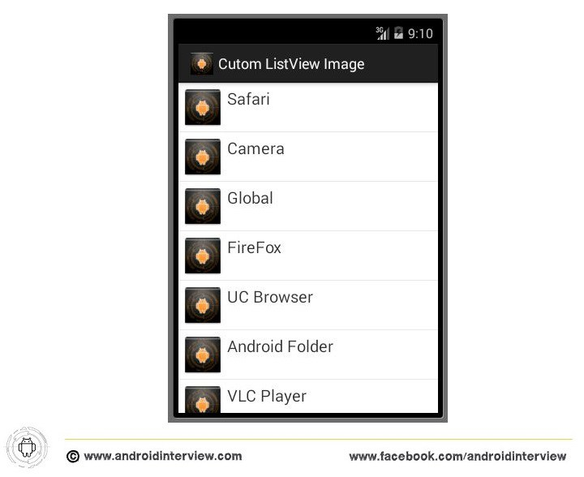](http://i1.wp.com/www.androidinterview.com/wp-content/uploads/2014/09/custom-listview-image-text2.jpg)

You can see each row have same icon If you want different icons or images for each row, you must need to create your own custom adapter. In next part B shows you how to achieve this.

Download Android Custom List with Same Image Source code :

Icon

**Android Custom Listview same Image Soruce code**3.81 MB

**[Android Custom Listview same Image Download](http://www.androidinterview.com/android-custom-listview-with-image-and-text-using-arrayadapter/)**

B. How to Create Custom Adapter of Display Image and TextView in ListView :

For better understanding Create new Project and Follow this steps :

1. Create an XML file in your **res/layout** folder and name it, for example, **mylist.xml**. (As previous Part)

2. Now Open “**res/layout/mylist.xml**” file and put this xml code it into file:

mylist.xml

XHTML



|  |  |
| --- | --- |
| 1  2  3  4  5  6  7  8  9  10  11  12  13  14  15  16  17  18  19  20  21  22  23  24  25  26  27  28  29  30  31  32  33  34 | <?xml version="1.0" encoding="utf-8"?>  <LinearLayout xmlns:android="http://schemas.android.com/apk/res/android"      android:layout_width="match_parent"      android:layout_height="match_parent"      android:orientation="horizontal" >        <ImageView          android:id="@+id/icon"          android:layout_width="60dp"          android:layout_height="60dp"  android:padding="5dp" />        <LinearLayout android:layout_width="wrap_content"          android:layout_height="wrap_content"          android:orientation="vertical">        <TextView          android:id="@+id/item"          android:layout_width="wrap_content"          android:layout_height="wrap_content"          android:text="Medium Text"          android:textAppearance="?android:attr/textAppearanceMedium"          android:layout_marginLeft="10dp"          android:layout_marginTop="5dp"          android:padding="2dp"          android:textColor="#33CC33" />      <TextView          android:id="@+id/textView1"          android:layout_width="wrap_content"          android:layout_height="wrap_content"          android:text="TextView"          android:layout_marginLeft="10dp"/>  </LinearLayout>  </LinearLayout> |

The preceding layout contains an ImageView and two TextViews.

3. To display a ListView in your activity, you need to add the *<ListView>* element to your UI, such as the**activity_main.xml** file:

*File : res/layout/activity_main.xml*

activity_main.xml

XHTML



|  |  |
| --- | --- |
| 1  2  3  4  5  6  7  8  9  10  11  12  13  14  15 | <RelativeLayout xmlns:android="http://schemas.android.com/apk/res/android"      xmlns:tools="http://schemas.android.com/tools"      android:layout_width="match_parent"      android:layout_height="match_parent"      tools:context="{relativePackage}.${activityClass}" >        <ListView          android:id="@+id/list"          android:layout_width="match_parent"          android:layout_height="wrap_content"          android:layout_alignParentLeft="true"          android:layout_alignParentTop="true" >      </ListView>    </RelativeLayout> |

4. Add 8 images to the **res/drawable-mdpi** folder (see Figure ).

[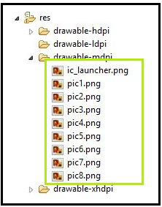](http://i0.wp.com/www.androidinterview.com/wp-content/uploads/2014/09/custom-listview-image-text4.jpg)

5. To populate each row using this newly created layout, you need to create a new custom array adapter. To do that, add a new Java class to the project and name it **CustomListAdapter.java** (see Figure).

[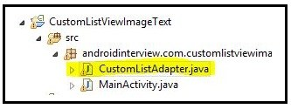](http://i1.wp.com/www.androidinterview.com/wp-content/uploads/2014/09/custom-listview-image-text5.jpg)

6. Open “**CustomListAdapter.java**” file and add following JAVA code.

*File : src/package-name/CustomListAdapter.java*

CustomListAdapter.java

Java



|  |  |
| --- | --- |
| 1  2  3  4  5  6  7  8  9  10  11  12  13  14  15  16  17  18  19  20  21  22  23  24  25  26  27  28  29  30  31  32  33  34  35  36  37  38  39  40 | package androidinterview.com.customlistviewimagetext;    import android.app.Activity;  import android.view.LayoutInflater;  import android.view.View;  import android.view.ViewGroup;  import android.widget.ArrayAdapter;  import android.widget.ImageView;  import android.widget.TextView;    public class CustomListAdapter extends ArrayAdapter<String> {    private final Activity context;  private final String[] itemname;  private final Integer[] imgid;    public CustomListAdapter(Activity context, String[] itemname, Integer[] imgid) {  super(context, R.layout.mylist, itemname);  // TODO Auto-generated constructor stub    this.context=context;  this.itemname=itemname;  this.imgid=imgid;  }    public View getView(int position,View view,ViewGroup parent) {  LayoutInflater inflater=context.getLayoutInflater();  View rowView=inflater.inflate(R.layout.mylist, null,true);    TextView txtTitle = (TextView) rowView.findViewById(R.id.item);  ImageView imageView = (ImageView) rowView.findViewById(R.id.icon);  TextView extratxt = (TextView) rowView.findViewById(R.id.textView1);    txtTitle.setText(itemname[position]);  imageView.setImageResource(imgid[position]);  extratxt.setText("Description "+itemname[position]);  return rowView;    };  } |

The CustomArrayAdapter class extends the ArrayAdapter base class.

7. To display the ListView using the new layout, add the following code to the **MainActivity.java** file:

*File : src/package-name/MainActivity.java*

MainActivity.java

Java



|  |  |
| --- | --- |
| 1  2  3  4  5  6  7  8  9  10  11  12  13  14  15  16  17  18  19  20  21  22  23  24  25  26  27  28  29  30  31  32  33  34  35  36  37  38  39  40  41  42  43  44  45  46  47  48  49  50  51  52  53  54  55  56  57  58  59 | package androidinterview.com.customlistviewimagetext;    import android.app.Activity;  import android.app.ListActivity;  import android.os.Bundle;  import android.view.View;  import android.widget.AdapterView;  import android.widget.AdapterView.OnItemClickListener;  import android.widget.ArrayAdapter;  import android.widget.ListView;  import android.widget.Toast;      public class MainActivity extends Activity{    ListView list;  String[] itemname ={  "Safari",  "Camera",  "Global",  "FireFox",  "UC Browser",  "Android Folder",  "VLC Player",  "Cold War"  };    Integer[] imgid={  R.drawable.pic1,  R.drawable.pic2,  R.drawable.pic3,  R.drawable.pic4,  R.drawable.pic5,  R.drawable.pic6,  R.drawable.pic7,  R.drawable.pic8,  };  *@Override*  protected void onCreate(Bundle savedInstanceState) {  super.onCreate(savedInstanceState);  setContentView(R.layout.activity_main);    CustomListAdapter adapter=new CustomListAdapter(this, itemname, imgid);  list=(ListView)findViewById(R.id.list);  list.setAdapter(adapter);    list.setOnItemClickListener(new OnItemClickListener() {    *@Override*  public void onItemClick(AdapterView<?> parent, View view,  int position, long id) {  // TODO Auto-generated method stub  String Slecteditem= itemname[+position];  Toast.makeText(getApplicationContext(), Slecteditem, Toast.LENGTH_SHORT).show();    }  });  }  } |

**Output of  Android Custom ListView with Image & Text in emulator :**

[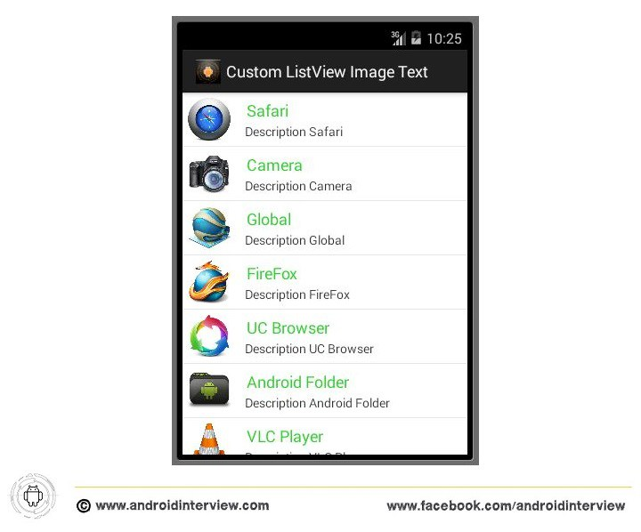](http://i2.wp.com/www.androidinterview.com/wp-content/uploads/2014/09/custom-listview-image-text6.jpg)

Download Android Custom List with Image and Text Source code :

Icon

**Android Custom Listview with Image and TextView Soruce code**6.58 MB

[**Android Custom Listview with Image & TextView Download**](http://www.androidinterview.com/android-custom-listview-with-image-and-text-using-arrayadapter/)

*Note : This example (Project) is developed in Eclipse Version Kepler,tested on Android 4.4.2 (KitKat Version) and SDK build-tools 23.0*